

**Linux System Gadget Driver Integration and Application Guidance**

Document version: V1.0.0

Update date: 04.01.2016

Applicability Table

|  |  |  |
| --- | --- | --- |
| No. | Product model | Description |
|  |  |  |
|  |  |  |
|  |  |  |
|  |  |  |
|  |  |  |
|  |  |  |
|  |  |  |

Copyright

Copyright ©2015Fibocom Wireless Inc. All rights reserved.

Without the prior written permission of the copyright holder, any company or individual is prohibited to excerpt, copy any part of or the entire document, or distribute the document in any form.

Notice

The document is subject to update from time to time owing to the product version upgrade or other reasons. Unless otherwise specified, the document only serves as the user guide. All the statements, information and suggestions contained in the document do not constitute any explicit or implicit guarantee.

Trademark

The trademark is registered and owned by Fibocom Wireless Inc.



Version Record

|  |  |  |
| --- | --- | --- |
| Version | Update Date | Remarks |
| V1.0.0 | 04.01.2016 | Initial version |
|  |  |  |
|  |  |  |

**Contents**

1 Introduction 5

1.1 Purpose 5

1.2 Scope 5

2 Instructions for Linux Gadget Driver 6

2.1 Linux Gadget Driver Architecture 6

2.2 Linux Gadget Driver Integration 7

2.2.1 Driver Configuration 7

2.2.2 Detailed Configuration Setup 7

2.2.3 Gadget Driver Configuration Confirmation 7

3 Install The Host Side Driver 8

3.1 Installing the Windows Host ACM Driver 8

3.1.1 Detailed Steps 8

4 Installing The 4G Modem’s Linux Device Driver 10

5 Installing The Device Side’s Bridge Application Tool 10

6 Useing The STT Application In the Host Side 10

6.1 Installing the STT Application 10

6.2 Configuration The Trace Channel 11

6.3 Start Capture The Trace 11

# Introduction

## Purpose

* This article is the guidance for gadget driver integration development activities for L8 series 4G module devices based on Linux systems. This document is mainly for driver developers for product developers based on the above systems.

## Scope

The document applies to the following:

* Linux2.6.38 and higher version.

# Instructions for Linux Gadget Driver

## Linux Gadget Driver Architecture

This gadget driver is a Linux USB gadget driver, a USB device side driver. It runs on a Linux system that has USB device side hardware; for example, a PDA, an embedded Linux system, or a PC with a USB development card.

The gadget serial driver talks over USB to either a CDC ACM driver or a generic USB serial driver running on a host PC.

The architecture of the gadget serial driver is shown in Figure 2-1:

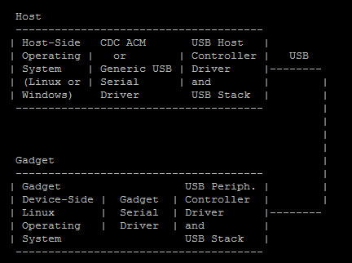

Figure 2-1 Architecture

Linux On the device-side Linux system, the gadget serial driver looks like a serial device. On the host-side system, the gadget serial device looks like a CDC ACM compliant class device or a simple vendor specific device with bulk in and bulk out endpoints, and it is treated similarly to other serial devices.

## Linux Gadget Driver Integration

### Driver Configuration

To use the gadget serial driver you must configure the Linux gadget side kernel for "USB Gadget Support", for “USB Gadget Drivers”, and for the "Serial Gadget" driver. All this are listed under "USB Gadget Support" when configuring the kernel. Then rebuild and install the kernel or modules.

### Detailed Configuration Setup

1. Open the Terminal tool, enter the kernel directory (it is assumed to be "/linux-3.0.8/ /home/ght"), and execute the <configuration> make command (it’s assumed to use standard menuconfig).
2. Complete configurations of gadget driver as the following guidelines:

Enter **“Device Drivers”→“USB support”→“USB Gadget Support”**menu and select USB Gadget Drivers(Serial Gadget(with CDC ACM and CDC OBEX support)) item in red border

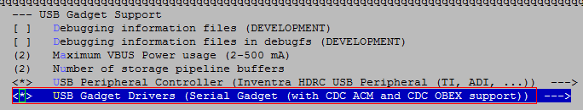

1. After the configuration, exit the configuration interface step by step by selecting “<Exit>”. And then select “<Yes>” and exit the save interface.
2. After completing configurations, run the make command to compile the modified kernel.

### Gadget Driver Configuration Confirmation

When the system starts up, execute the dmesg command and check the kernel messages. The information as shown in the red box in Figure 2-2 indicate that the gadget driver in the system has been successfully configured.

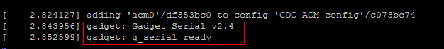

Figure 2-2 DriverLoad

After this gadget driver has been set up you should then see a /dev/ttyGS0 node:



Figure 2-3 Node

# Install **The Host Side Driver**

If gadget serial is loaded as an ACM device you will want to use either the Windows or Linux ACM driver on the host side. If gadget serial is loaded as a bulk in/out device, you will want to use the Linux generic serial driver on the host side. Follow the appropriate instructions below to install the host side driver.

## Installing the Windows Host ACM Driver

To use the Windows ACM driver you must have the "linux-cdc-acm.inf" file (provided along this document) which supports all recent versions of Windows.

### Detailed **Steps**

When the gadget serial driver is loaded and the USB device connected to the Windows host with a USB cable, Windows should recognize the gadget serial device and ask for a driver. Tell Windows to find the

driver in the folder that contains the "linux-cdc-acm.inf" file.

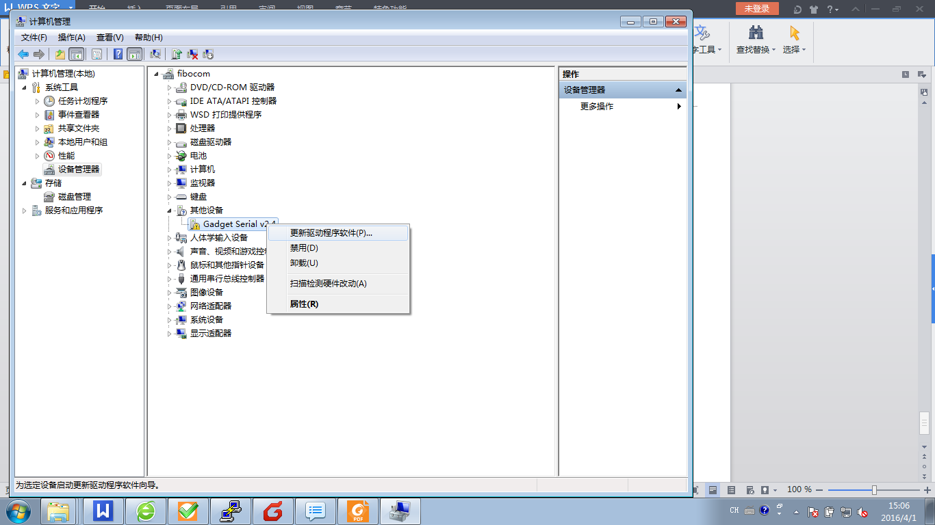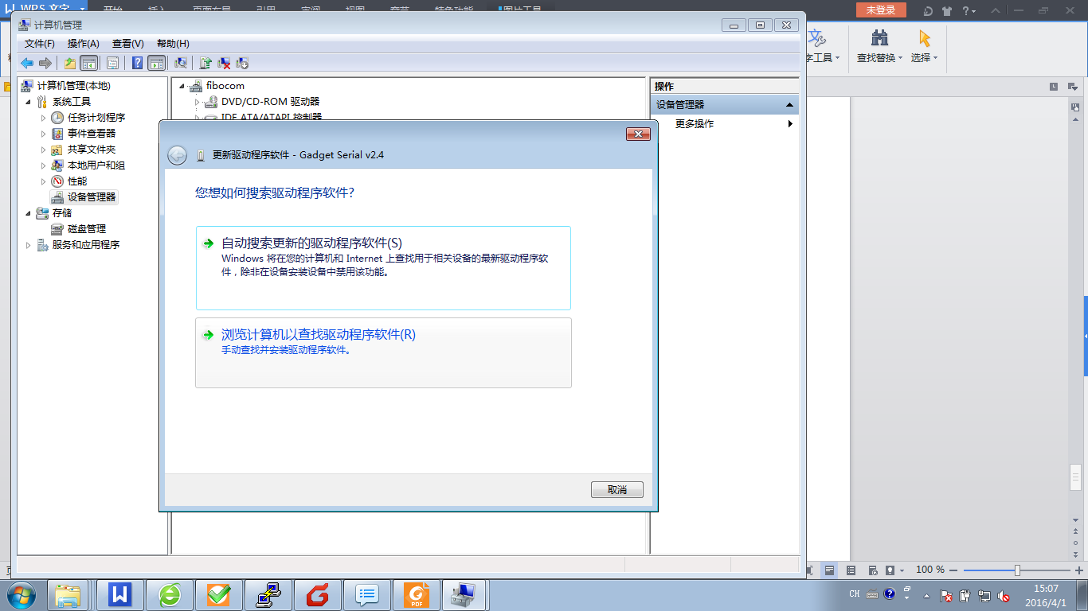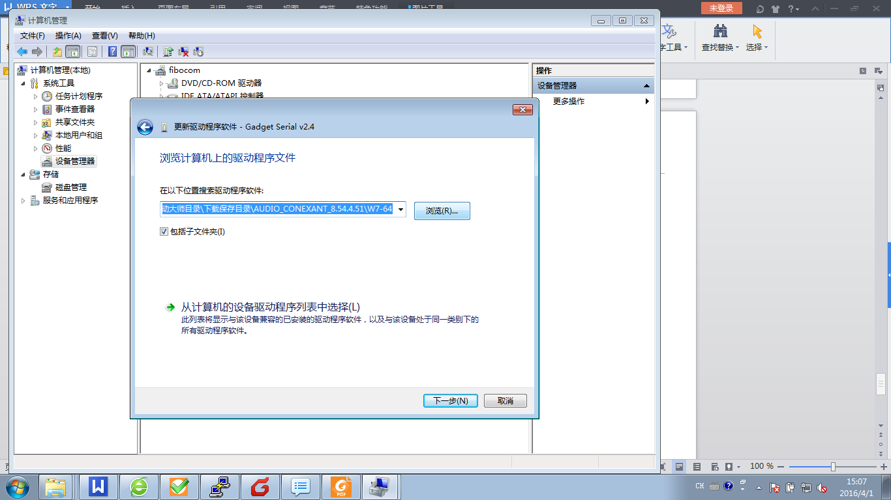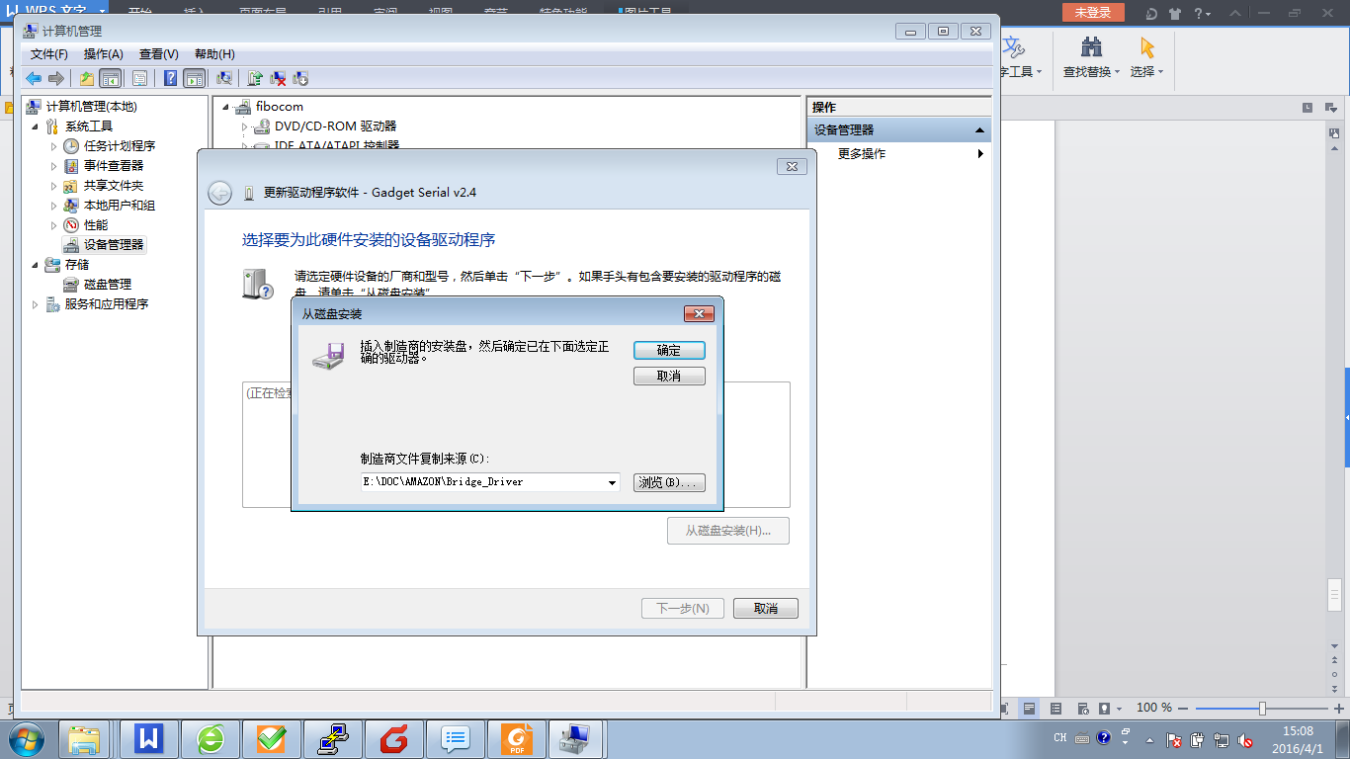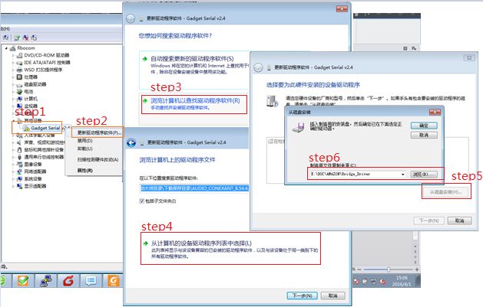

When the Driver load sucessfully, a com port wil be shown.



Then use your serial tool to open the port in the host side. And execute ‘cat /dev/ttyGS0 &’ in the device side. Try to send some words form host side and the device side will get the message as the bellow picture shows.

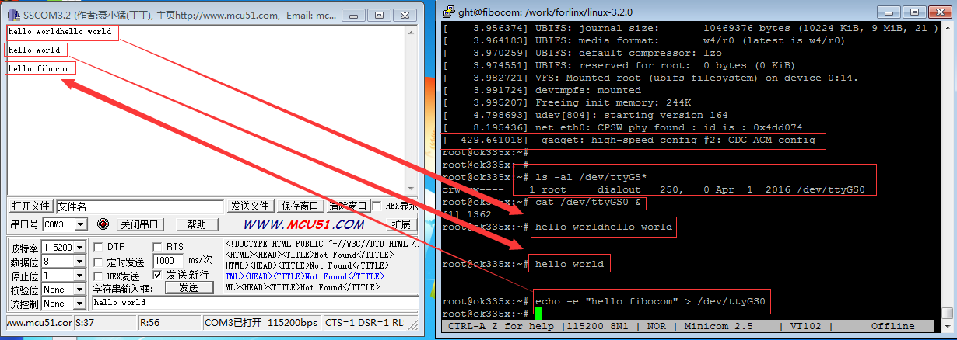

And your need to kill the cat command in the device side after your test the port.

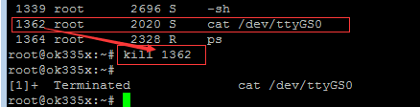

# Installing The 4G Modem’s Linux Device Driver

Follow the docmount “FIBOCOM_L8 Family System Driver Integration and Application Guidance_V2.1.0.docx” to install the 4G modem’s driver.

# Installing The Device Side’s Bridge Application Tool

The tool named GhtBridgeTool, it’s use to receive the trace data from the 4G modem’s trace port, and send the trace data to ttyGS0. And the Host side’s serial port will get the trace data from ttyGS0.Try to excute “GhtBridgeTool -m /dev/ttyACM1 -p /dev/ttyGS0” command to run the application progoram in the device side.

# Useing The STT Application In the Host Side

The STT application is used to capture the 4G modem’s trace data from the trace port.

## Installing the STT Application

Install jdk-7u67-windows-i586.exe before you run STT setup.exe, it’s need by STT’s setup.exe. When you installed the STT successfully, Double click STT’s shotcut icon in the desktop to run the application. The shotcut icon shown as below:

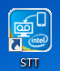

## Configuration The Trace Channel

In STT’s File->Configuration->Connection->Trace Channel menu, select the Com Port as 3.1 chapter, and the baud is 115200.

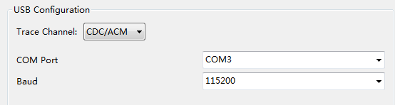

In STT’s File->Configuration->Session->Session Path menu, you can specity the directory to save the data.

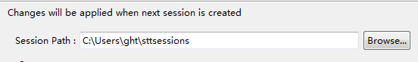

## Start Capture The Trace

In the tool menu, you can see the Start Trace button in the left side, and the next is Stop Trace button. Click the Start button to capture the trace, Click the Stop button to stop capture.

Befroe Click Start button:

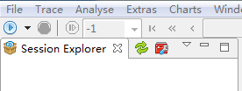

After Click Start button, The Stop Trace button turn to red color.

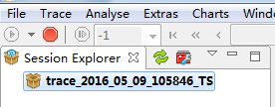

Click the Stop Trace button, and Right click “trace_2016_05_09_105846_TS”, click Open directory menu, and the xxx.istp file is the trace file, copy this file for us.

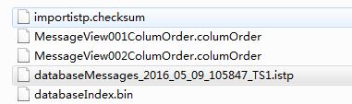

[ 429.641018] gadget: high-speed config #2: CDC ACM config

